AWS Lambda

1.Start and Stop Ec2 Instances Using AWS Lambda
Objective
Create two AWS Lambda functions to start and stop an EC2 instance automatically.
Step-by-Step Procedure
Step 1: Log in to the AWS Management Console.
Step 2: Navigate to AWS Lambda → Functions.
Step 3: Click Create function.
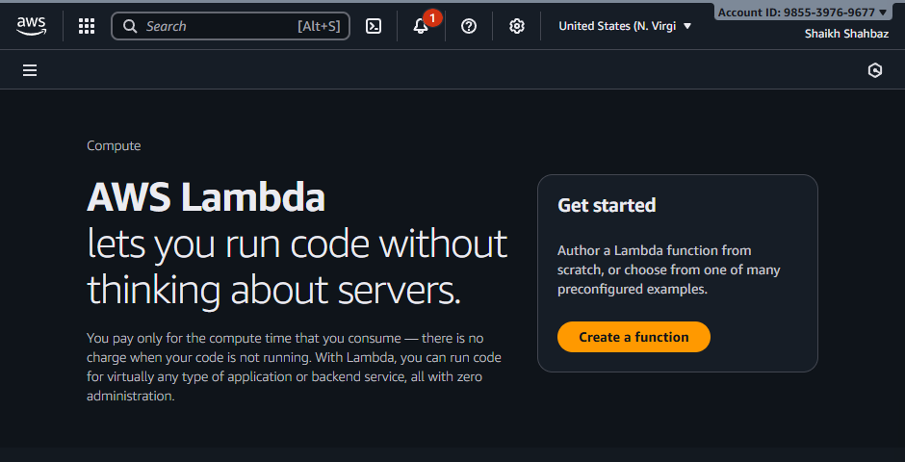
Step 4: Select Author from scratch.
Step 5: Enter function name:
start-ec2-lambda
Step 6: Select runtime:
Python 3.10
Step 7: Choose Use an existing role (role will be created in Task 2).
Step 8: Click Create function.
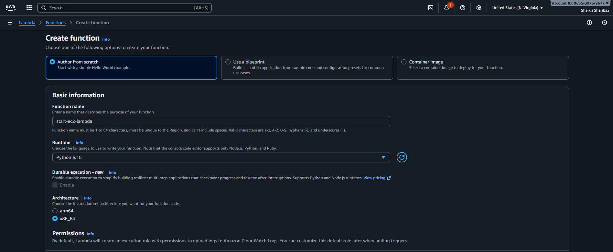
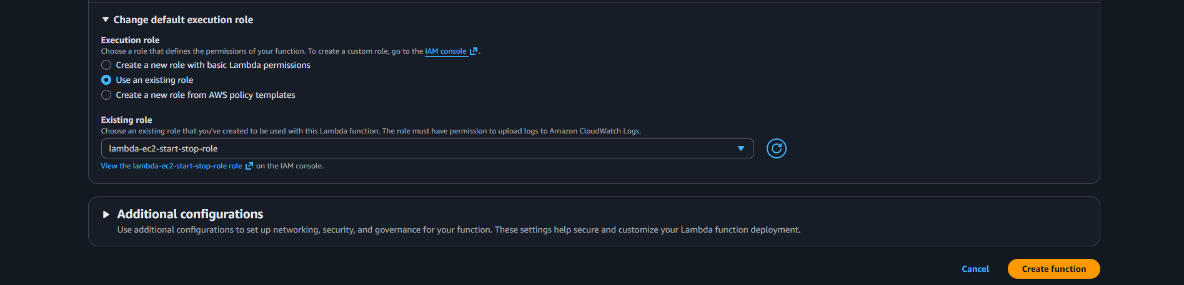
Step 9: Repeat Steps to create another function named:
stop-ec2-lambda
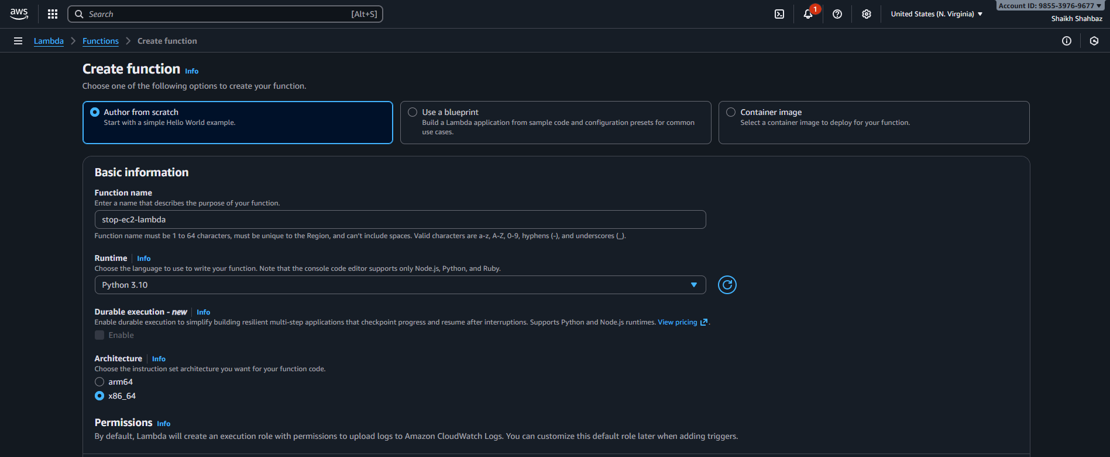
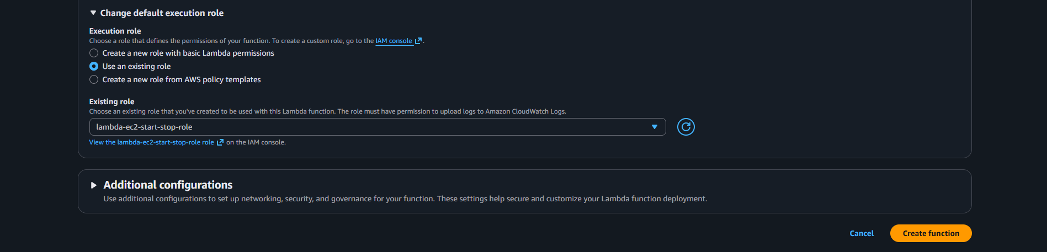
Validation:
Start-ec2-lambda
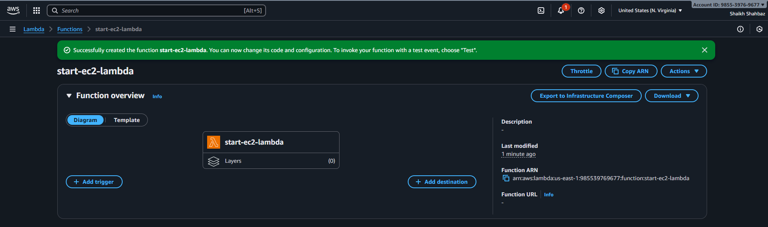
Stop-ec2-lambda
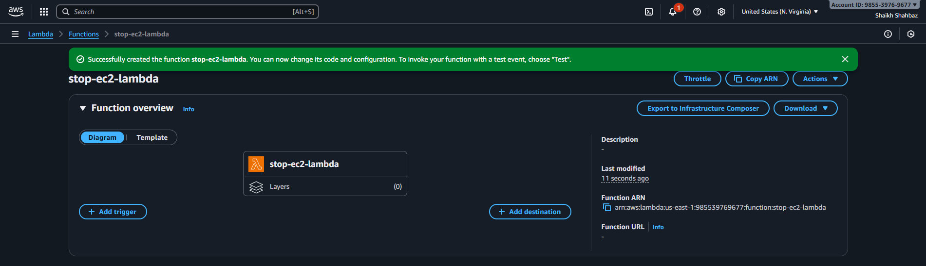

2.Add an IAM role to Lambda Function to grant it necessary permissions to interact with other AWS services securely.
Objective
Grant Lambda permissions to interact securely with EC2 and CloudWatch.
Step-by-Step Procedure
Step 1: Navigate to IAM → Roles.
Step 2: Click Create role.
Step 3: Select AWS Service as trusted entity.
Step 4: Choose Lambda and click Next.
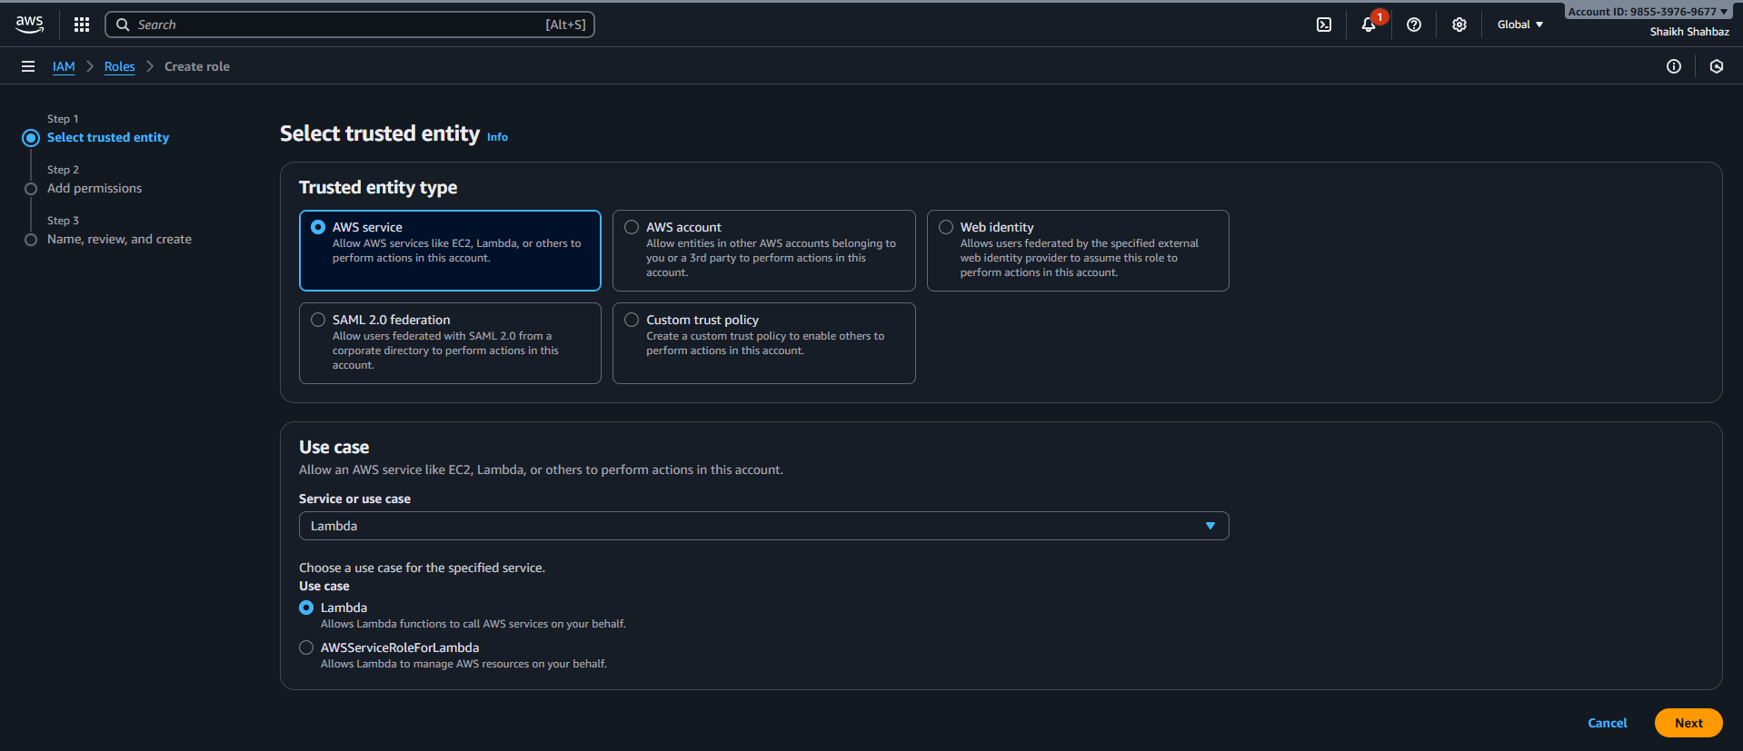
Step 5: Attach the following policies:
- AmazonEC2FullAccess
- CloudWatchLogsFullAccess
Step 6: Click Next.
Step 7: Enter role name:
Lambda-EC2-Start-Stop-Role
Step 8: Click Create role.
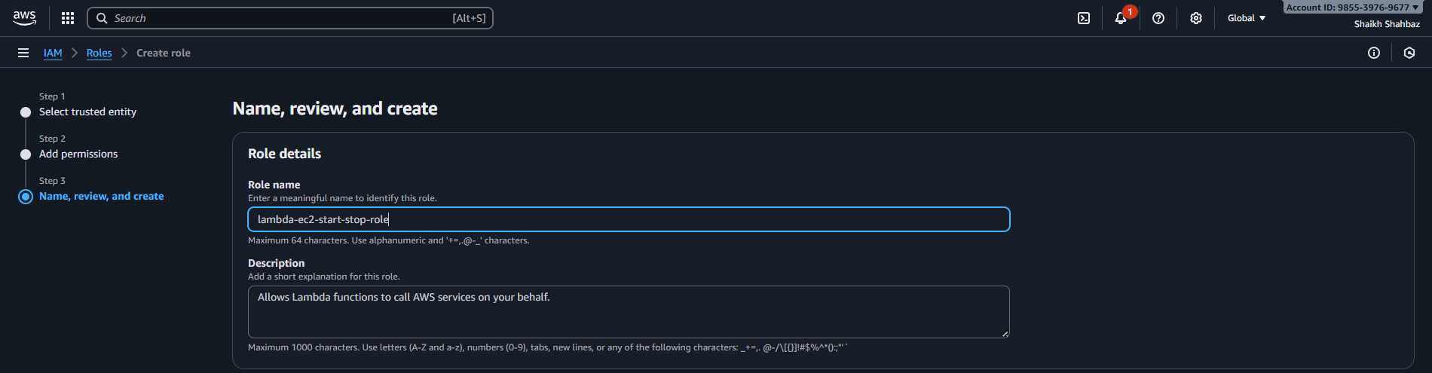
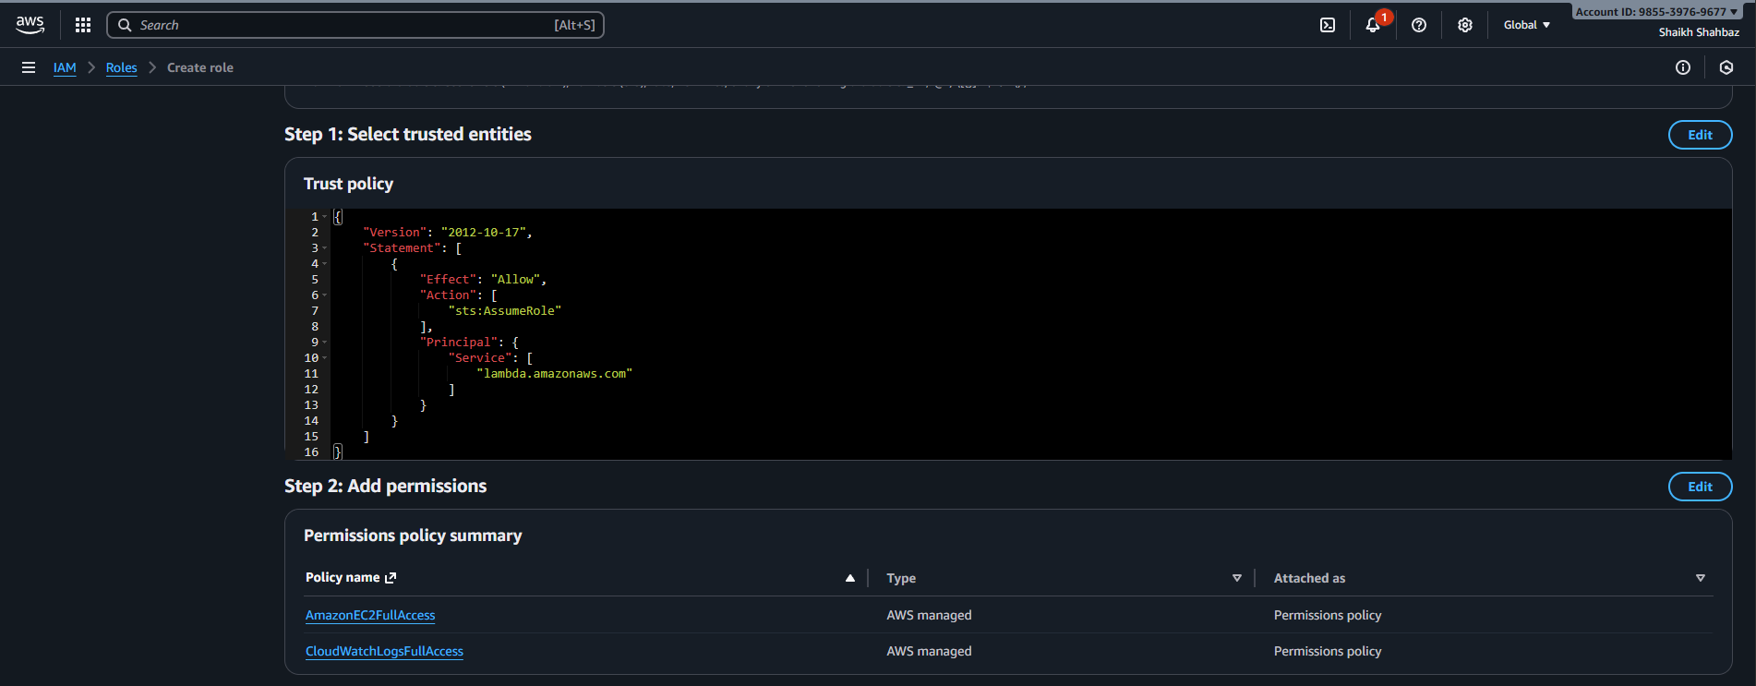
Step 9: Attach this role to both Lambda functions (start-ec2-lambda and stop-ec2-lambda).
Role attached to Start-ec2-lambda

Role attached to Stop-ec2-lambda


3.Change the code according to our requirements :
- To start and stop an EC2 instance using Python, you use the Boto3 library, which is the AWS SDK for Python.
- Here are two separate Python scripts. Each script performs a single action on a specific EC2 instance identified by its instance ID.
Objective
Use Boto3 to start and stop a specific ec2 instance.
Script 1: Start ec2 instance
Step 1: Open start-ec2-lambda
Step 2: Go to Code Tab.
Step 3: Replace the default code with:
Step 4: Click Deploy.
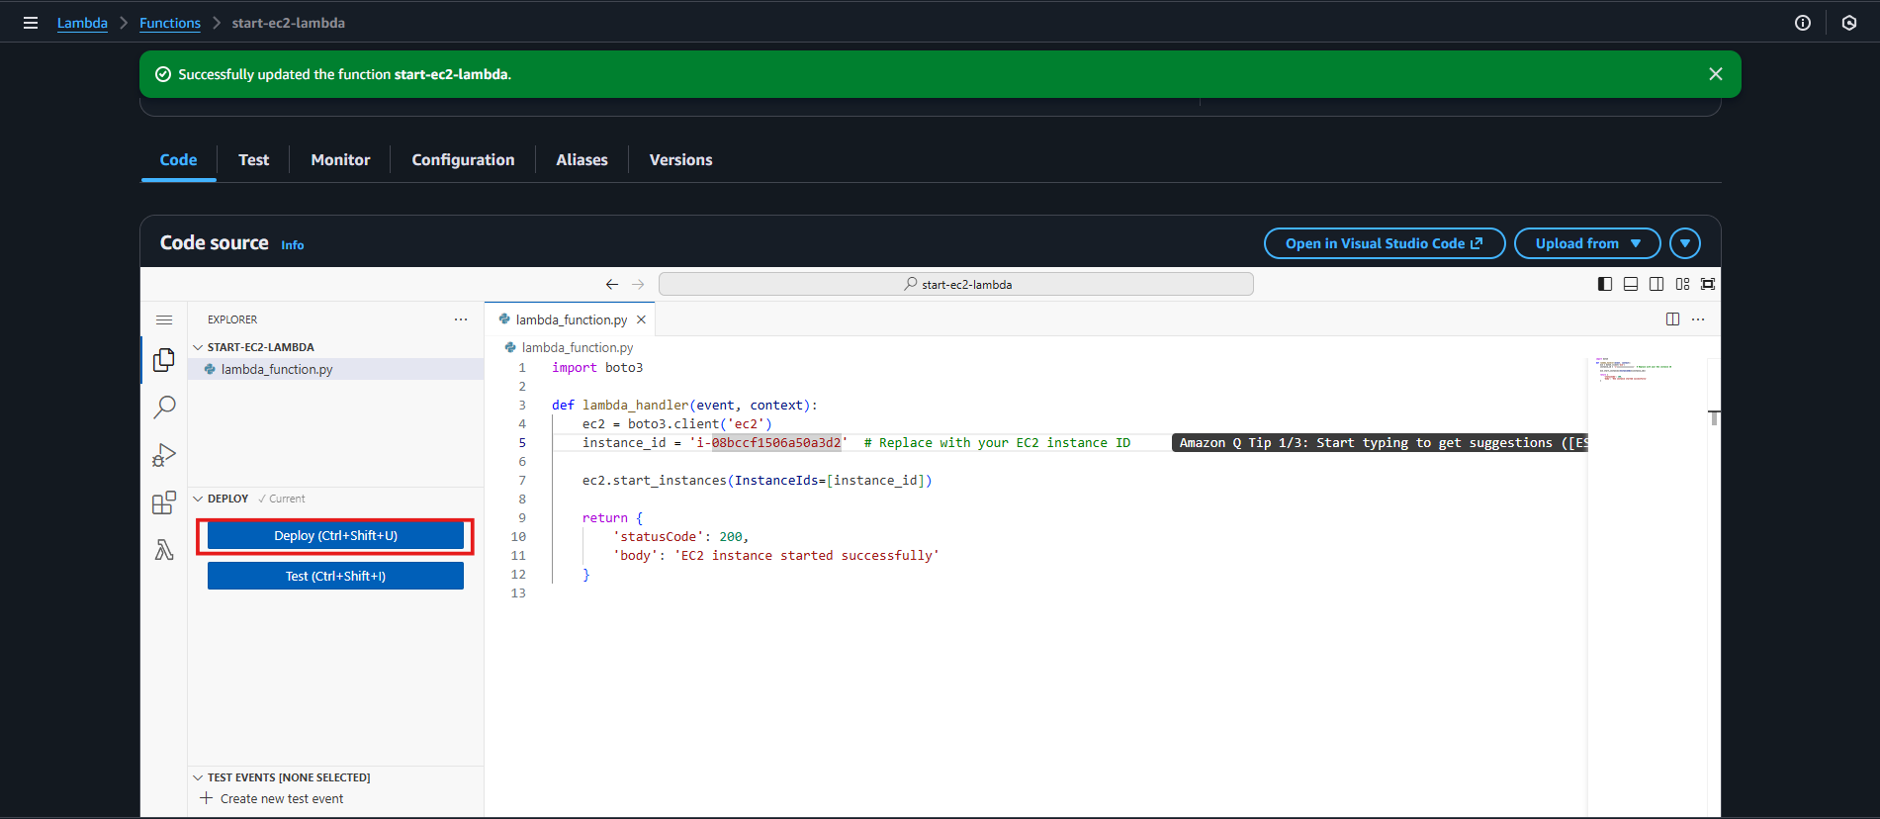
Script 2: Start ec2 instance
Step 1: Open stop-ec2-lambda
Step 2: Go to Code Tab.
Step 3: Replace the default code with:
Step 4: Click Deploy.
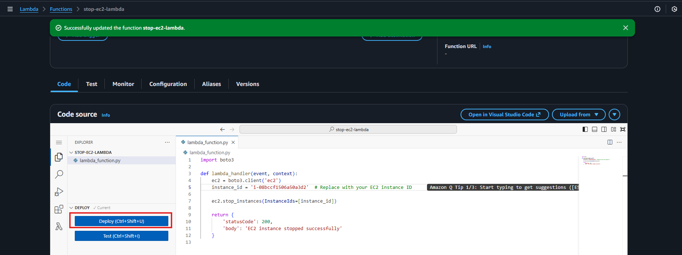

4.Add two scheduled triggers for Lambda function using AWS Event Bridge :
The first trigger, named start-ec2, is set to run a function every day at 16:30 PM local time zone to start an EC2 instance.
Objective
Automate EC2 start and stop on a daily schedule.
Trigger 1: Start EC2 Instance
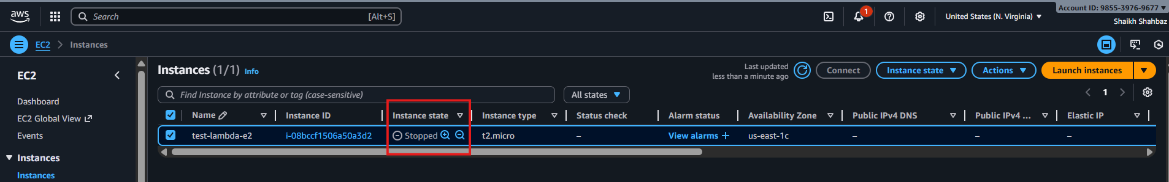
Step 1: Navigate to Amazon EventBridge → Rules.
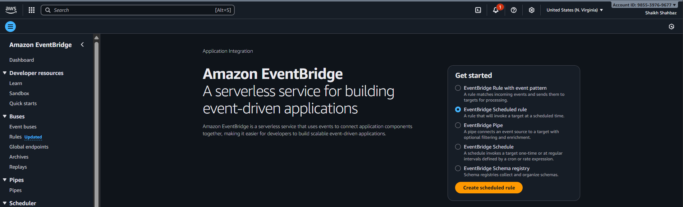
Step 2: Click Create rule.
Step 3: Rule name:
start-ec2
Step 4: Select Schedule.
Step 5: Choose Cron expression.
Step 6: Enter:
cron(30 16 * * ? *)
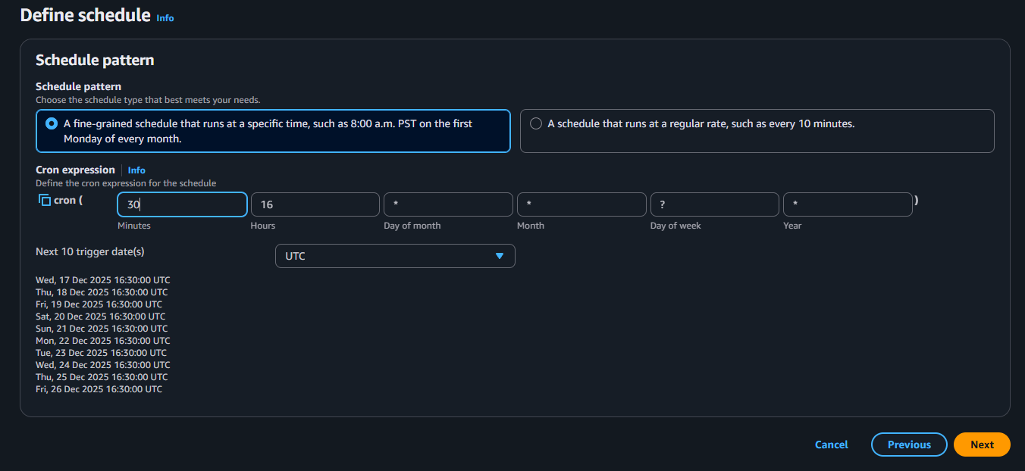
Step 7: Target → Lambda function.
Step 8: Select start-ec2-lambda.
Step 9: Click Create rule.
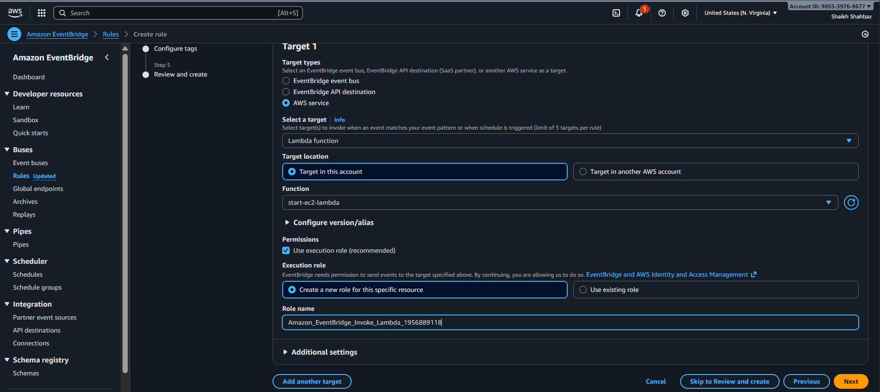
Runs daily at 16:30 PM local time xone.
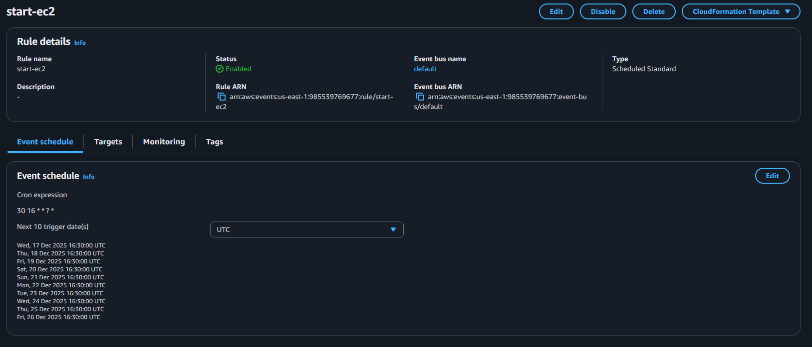
Validation:

Here we can see that earlier my ec2 instance is in stop status and now it is active and running.
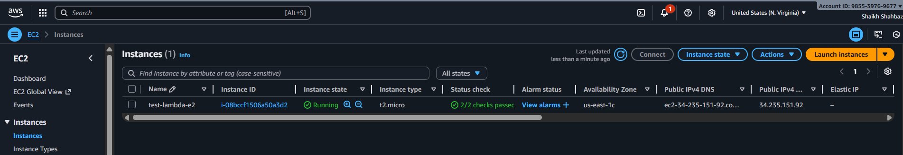

The second trigger, named stop-ec2-rule, is set to run a function every day at 16:40 PM local time zone to stop an EC2 instance.
Trigger 2: Stop EC2 Instance
Step 1: Click Create rule.
Step 2: Rule name:
stop-ec2-rule
Step 3: Select Schedule.
Step 4: Cron expression:
cron(40 16 * * ? *)
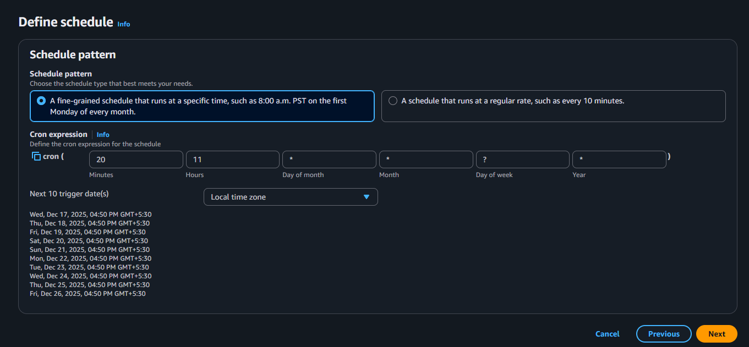
Step 5: Target → Lambda function.
Step 6: Select stop-ec2-lambda.
Step 7: Click Create rule.
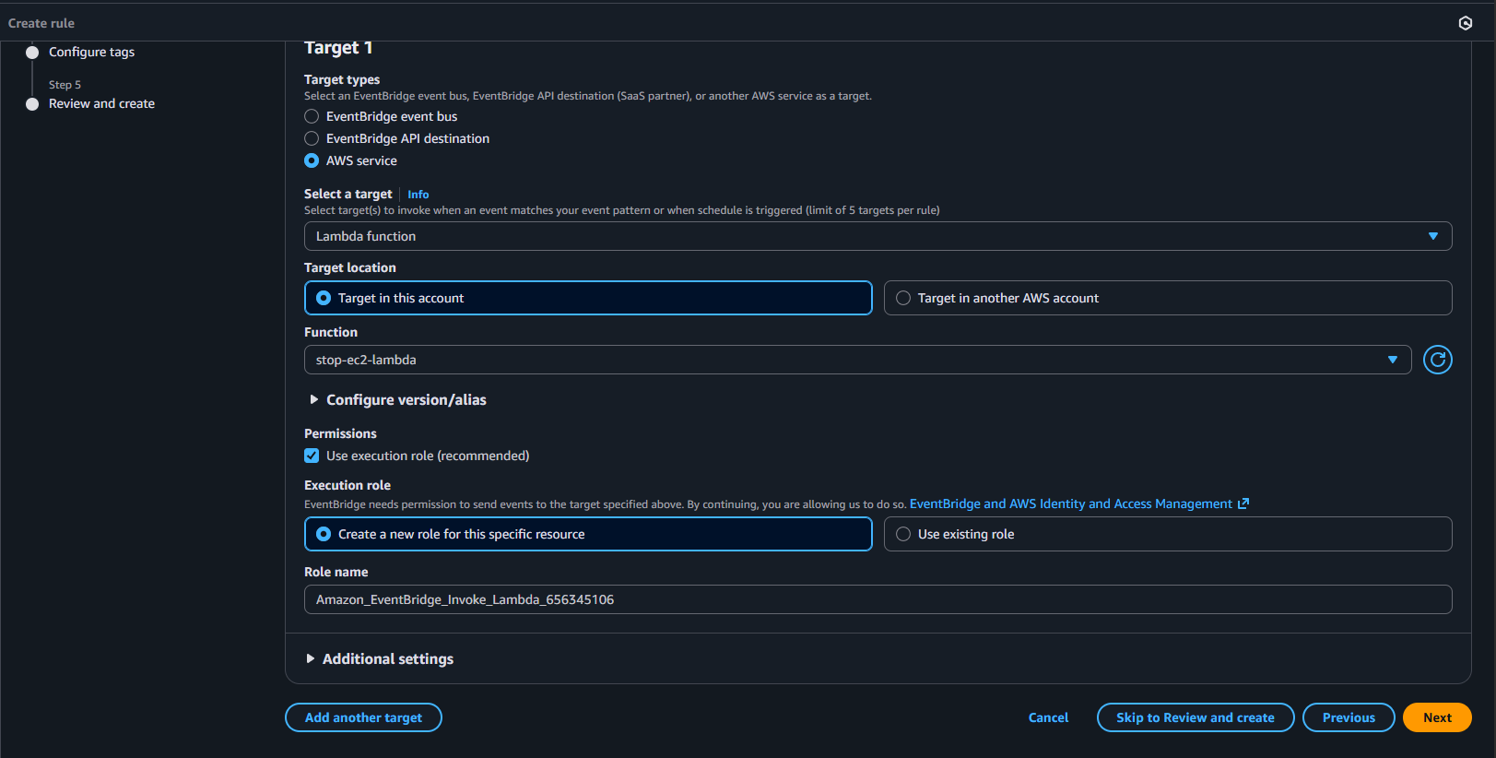
Runs daily at 16:40 PM local time zone.
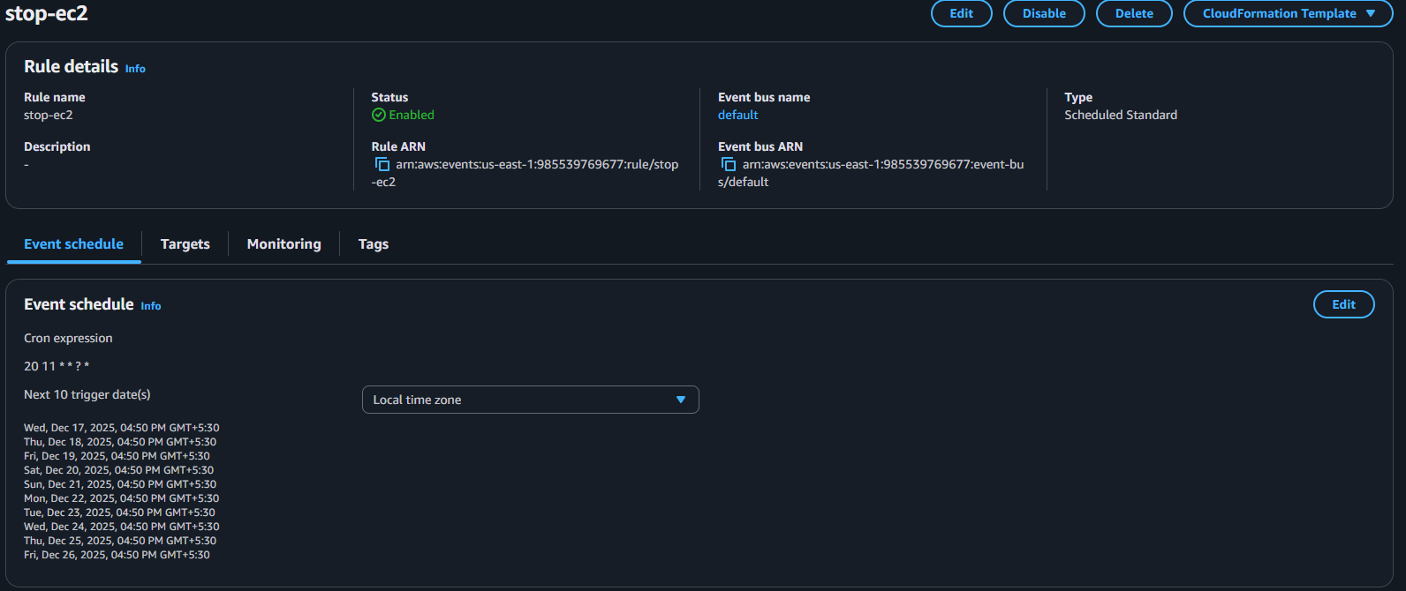
Validation:

Here we can see that earlier my ec2 instance is in running status and now it is stopped.
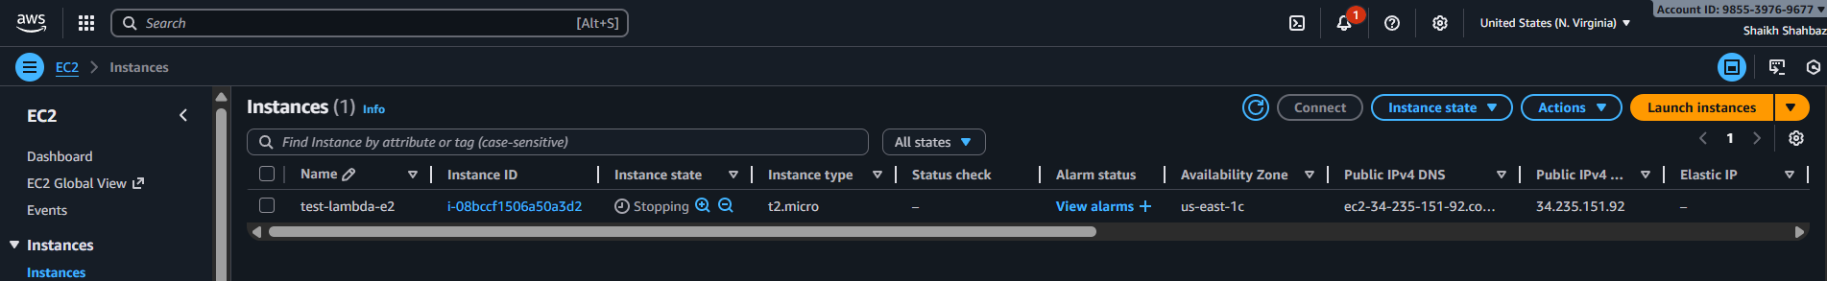
5.Check the CloudWatch logs
Objective
Verify that Lambda functions executed successfully.
Step-by-Step Procedure
Step 1: Navigate to CloudWatch → Log groups.
Step 2: Open:
/aws/lambda/start-ec2-lambda
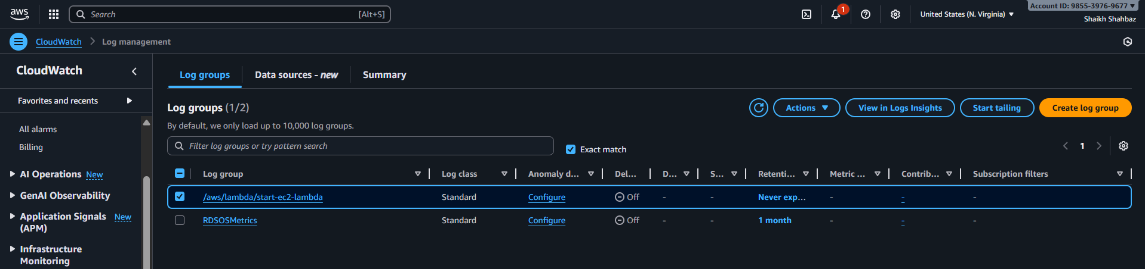
Step 3: Open the latest log stream.
Step 4: Verify successful start message.
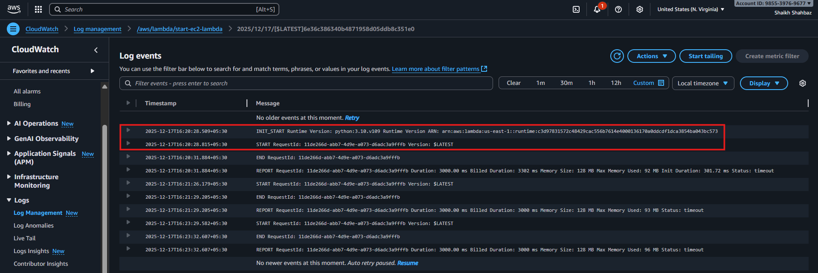

Step 5: Open:
/aws/lambda/stop-ec2-lambda

Logs confirm Lambda execution and EC2 state changes.
